“Gesture-Controlled Autonomous Navigation System using Robot Operating System 2”

DRAWINGS

Figure-I Block Diagram of the proposed system

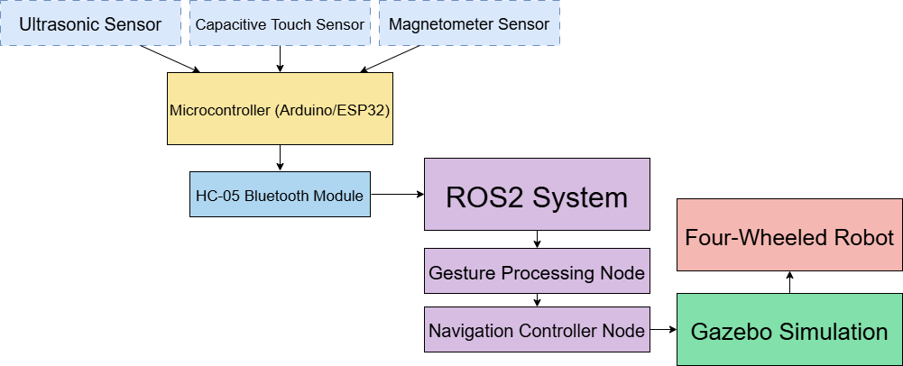

FIGURE 2: Working model of the proposed system
